邀请函 Invitation

- 背景介绍/Background Information

丝绸之路国际生态产业博览会暨绿色有机产品（张掖）交易会（以下简称“张交会”）是丝绸之路上第一个以“国际生态产业”为展示主体的博览会，已经成功举办了两届。
第三届张交会将于9月9日-12日继续在中国张掖国际展览中心举办。同时，为了使社会各界深入了解中国西部的农产品、药品、畜产品、种子、户外旅游用品等特色产品，大力推广张掖生态旅游的发展，大会同期将举办张交会生态产业嘉年华等系列活动。届时，将邀请生态产业发达国家的领军人物和业界泰斗莅临参观指导，为您带来生态产业前沿资讯和先进的科学解决办法，共同分享农业、畜牧业在技术运用、产品推广、品牌塑造等领域的最新资讯。张交会累计展示面积达6万平方米，共吸引境外15个国家和地区、国内31个省市区的千余家企业参展参会。国内外观众累计达20万余人次，现场交易额5173万元人民币，签约额达1.13亿元人民币，意向投资额达30多亿元人民币。
The Silk Road International Ecological Industry Expo-Green Organic Products (Zhangye) Trade Fair(here after refer to as “Zhangye Trade Fair”) is the first exposition that rely “International ecological industry”as the main body to show,has been successfully held twice.
The Third Skill Road International Ecological Industry Expo-Green Organic Products (Zhangye) Trade Fair will be held in September 9th-12th, still in Zhangye International Exhibition Center at the same time,Vigorously promote the development of ecological tourism,in order to make the social from all walks of life have a thorough understanding of China western agricultural products,medicine,animal by-products,seed,outdoor tourism supplies and so on.The carnival will be held in the ecological industry and other series of activities.On the occasion,Ecological industry in developed countries will be invited to leaders and industry leading to visit the guidance,to bring you the ecological industry leading edge information and advanced scientific solution, share the agriculture and animal husbandry in technology, product promotion, brand building in areas such as the latest information.“Zhangye Trade Fair”total display area of 60000 square meters, attracting overseas in 15 countries and regions, domestic 31 provinces, more than thousands of enterprises to participate in the exhibition. The audience at home and abroad are more than 2000,00.The turnover of the exhibition is 51.73 million yuan, and the signing forehead is 113 million yuan, the turnover of intention invest is more than 30 million yuan.

二、展会回顾/Retrospect of Exhibition
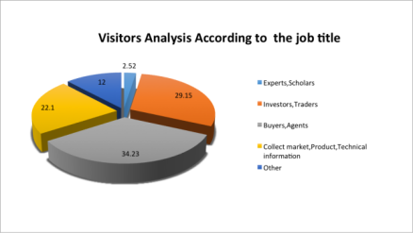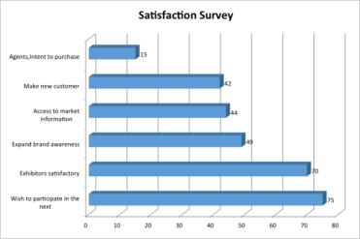
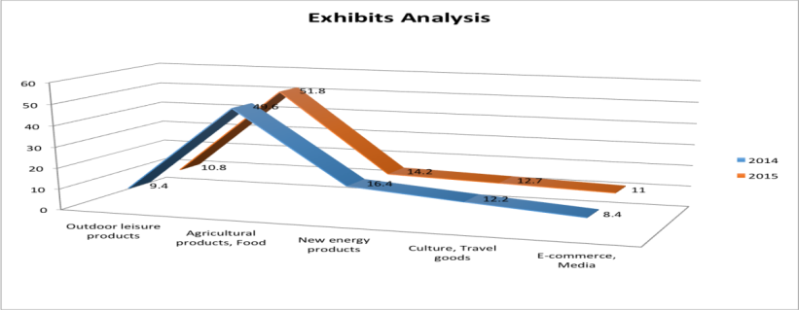

展会现场照片/Photos of Exhibition Site
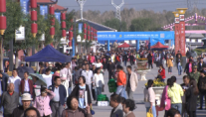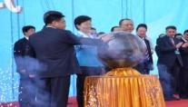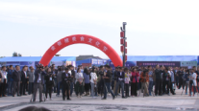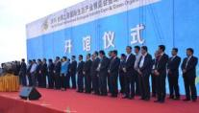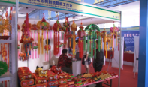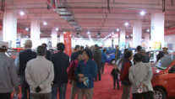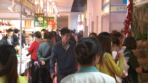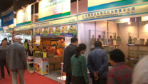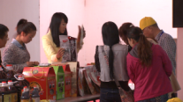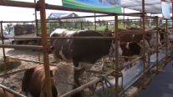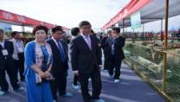

同期论坛及活动照片/Photos of Activities Scene
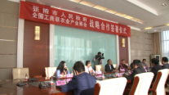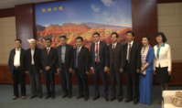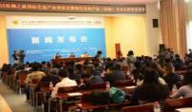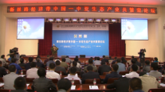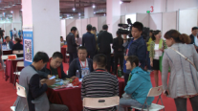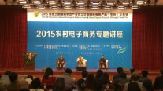

三、展会概况/General Situation Survey
展会时间：2016年9月9日-12日
Date：September 9-12, 2016
展会地点：张掖国际会展中心（玉水苑）
Place：Zhangye International Exhibition Center
（Zhangye Binhe New District Yushui Garden ）
展会规模：50,000平米
Scale:50,000m²
主办单位(Sponsors)：
全国工商联农业产业商会
China Agriculture Industry Chameber of Commerce
农民日报社
Farmers' Daily
中国农业产业化龙头企业协会
China Association Of Agricultural Leading Enterpries
中国国际贸易促进委员会甘肃省委员会
Gansu Committee of CCPIT
甘肃省工商业联合会
Gansu Federation ofindustry and Commerce
张掖市人民政府
Zhangye Municipal People's Government
承办单位(Organizer)：
谊和永邦（北京）会展有限公司
Beijing Exhibition Co., Ltd.
张掖市商务局
Commerce Bureau Of Zhangye
中国国际贸易促进委员会张掖市支会
Zhangye Committee of CCPIT
支持单位(Supperter)：
甘肃省商务厅
Department of Commerce of Gansu Provice

展出范围：种子制品及深加工产品展区；绿色农业及有机农产品展区；畜牧产品展区；产品设备展区；生态旅游、文化、户外休闲运动产品展区；电子商务展区；消费品展区。
Exhibiting Products Group:Seed products and deep-processing products exhibition; Green agriculture and organic products exhibition; Exhibition of livestock products; Products and equipment exhibition; Eco-tourism, Culture, Outdoor sports and leisure products exhibition; Exhibition of E-commerce; Consumer goods exhibition.

四、配套活动/Activities and Conference：
张交会生态产业发展论坛及嘉年华等系列活动
The Ecological industry carnival will be heldand other series of activities.

- 展位类型、配置和展位费用/Exhibition Booth & Fees：

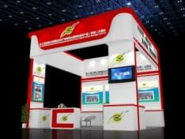 | 室内特装/Indoor Raw spaceprice:  光地36平米起租，每平米400元人民币；  USD80/㎡ (The minimum area is 36㎡)Raw space will be charged  特装管理费：30元/㎡/construction management fees:USD5/㎡  无任何配置，参展商自行搭建。另需缴纳施工管理费和电费/No facilities will be offered to Raw space Booth.
室外特装/Outdoor Raw space price:
光地36平米起租，每平米250元人民币；
USD50/㎡ (The minimum area is 36㎡)Raw space will be charged)
特装管理费：30元/㎡/ construction management fees:USD5/㎡
无任何配置，参展商自行搭建。另需缴纳施工管理费和电费/No facilities will be offered to Raw space Booth.
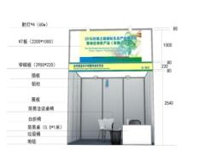 | 标准展位：5000元人民币（3mX3m=9㎡）  Standard Booth Price：USD1000 （3㎡*3㎡=9㎡）  配置Facilities：楣板/name banners、1个咨询台/1 reception desk、  2把椅子/2chairs、4盏射灯/4 spot lights、1 basic electricity(220V,50W)(1个基本电源）

会刊广告、其他广告/Other Advertisments
Description | Unit Price | 广告位 | 单价
Back cover | USD500/Page(140*210mm) | 封底 | 3,000元RMB(140*210mm)
The second front cover | USD500/Page(140*210mm) | 封二 | 3,000元RMB(140*210mm)
The third front cover | USD350/Page(140*210mm) | 封三 | 2,000元RMB(140*210mm)
Inside color page | USD200/Page(140*210mm) | 彩色内页 | 1,000元RMB(140*210mm)
Inside black page | USD100/Page(140*210mm) | 黑白内页 | 500元RMB(140*210mm)
Advertisment tickets ad | USD200/5,000 sheets  (210mm*90mm) | 参观劵 | 2,000元RMB/5,000张(210mm*90mm)
Exhibition/Visitor Card | USD700 | 证件 | 4,000元RMB
Air balloon ad | USD300 for each one | 空飘气球 | 1,500元RMB/个
Caigongmen ad | USD350 for each one | 彩虹门广告 | 2,000元RMB/个
Road Flag ad | Price can be available upon request | 道旗广告 | 详细价格备索
Printing advertisement out of the exhibition hall | Price can be available upon request | 展馆大型喷绘画面 | 详细价格备索
注：其他广告、赞助方案等请联系组委会。
Note: Other advertising, sponsorship programs, please contact the organizing committee.

六、参展条件/Exhibition Condition
具有《营业执照》的相关行业企业。
The enterprise has the Industry and Commercial Business License.

- 展会日程安排(Exhibition Schedule)
布展时间：2016年9月7日-8日（9:00-18:00）
展览时间：2016年9月9日-12日（9:00-18:00）
撤展时间：2016年9月12日（14:00）
[注意：本届展会报名时间截止时间为2016年8月9日]
Move-in Date:September 7-8,2016(9:00-18:00)
Exhibition Date:September 9-12,2016(9:00-18:00)
Move-out Date:September 12（14:00）
(Note:The application deadline for this exhibition is August 9,2016)

八、参展程序(Participation Procedures)
- 参展单位收到邀请函；
- 填写参展申请表加盖公章传真、电邮、邮寄至组委会；
- 组委会对申请者资格审核并确定展位，传真、电邮、邮寄《参展申请表》和《收费通知》至申请单位；
- 参展企业在收费通知书规定时间内汇款，并将汇款底单传真、电邮、邮寄至组委会；
- 款到账后组委会发出《展位确认书》；
- 参展单位执《展位确认书》到现场报道布展。
- Exhibitors received the invitation.
- Fill out the application form with stamp by fax、email、Mail it to the organizing committee.
3、The organizing committee for the applicant qualification review and determine the booth, fax, E-mail, mail it to apply for the unit of“The application form”and“Charge notice”.
4、Enterprises within the time schedule of the charge notice the remittance，And fax the remittance email, mail it to the organizing committee.
5、The organizing committee issued “The booth confirmation”after receive the payment.
6、Exhibitors take “The booth confirmation”to arrange the exhibition on the spot.

- 组委会联络处(Committee Office)：
谊和永邦（北京）会展有限公司 /Beijing Exhibition Co.,Ltd.
地址(Address):北京市西城区月坛北街26号恒华国际C座811室/Rm.811,Henghua Internatioal business,No.26,Yuetan Northstreet,Xicheng district,Beijing.

邮编(Code）：100045
电话（Phone）:0086-10-58566990/6923/5691/5361
传真（Fax）:0086-10-58566652
网址（Web）:www.exposilkroad.com
邮箱（E-mail）:dp5@expobj.com

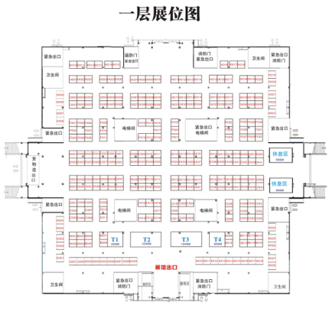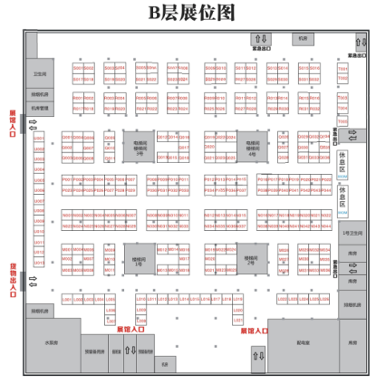
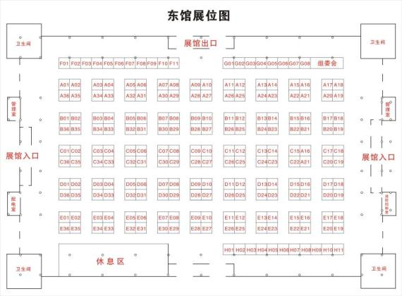
黑点为柱子，0.6*0.6M/ Black dots mark for a pillar(0.6*0.6m)
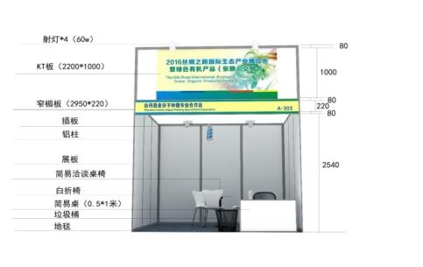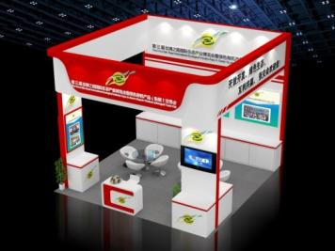

Meidia Publicity /媒体中心



